<THE BUS TICKET SYSTEM>

Object Design

<1.0>

<Date>

< DOĞAN SARIBAŞ

FEYZULLAH BERKAY DANIŞ

DENİZ ÇALIŞKAN

NURSENA KARAKULAH >

Prepared for

SE301 Software Engineering



Table of Contents

1. Introduction 1

1.1. Object Design Trade-offs 1

1.2. Interface Documentation Guidelines 1

1.3. Definitions, Acronyms, and Abbreviations 1

1.4. References 1

2. Packages 1

3. Class Interfaces 1

OBJECT DESIGN DOCUMENT

# Introduction

## Object Design Trade-offs

The project name is: Bus Ticket Reservation/Sell System. The website is about reservation and selling ticket. All implementation of user interface, database implementation and function are our own original work. We built all of them. We worked with MSQLi extension and and it works only with MYSQL databases. MYSQLi also offers a procedural API so that we worked with the procedural side of MYSQLi.

Also we built the minimum functionality required to draw user interest. To ensure that we waste the space but this gives us the time efficiency from the user side while they using the system. To achieve highest possible execution speed, that’s mean to heal the performance, the system lost its adaptability.

## Interface Documentation Guidelines

In this system, object-design principle had applied. There are three groups of graphical design in this project. First graphical design was made for User side, the second was made for Admin side and third was for officer. User panel has also two groups; Visitor and Registered User. These two designs are similar to each other.

On the user side, there are some of criterias. For instance; user may understand the site easily and do his/her actions easily on the site, user can perform the functions such as buy ticket or view information about ticket that she or he bought they can see campaigns and feedbacks. The side should be understandable. In addition to these functions, Registered User can also reserve bus tickets write comments , send message to the officer, take advantage of the campaigns.

The Admin panel, is more complex according to user-side. However, it is also easy to use for an admin. Menus are clearly identified on the panel. An admin can add trips to the site or cancel trips , add new campaign, admin can cancel tickets and approve/reject feedbacks.

The Officer panel, is the least complex, Officer can perform functions such as reading the messages from registered users and send them messages.

## Definitions, Acronyms, and Abbreviations

Viatorem is designed with using php, html, and mysql.

Admin: Admin is a user who is responsible from the system.

Visitor: A user who is not logged in to system.

Registered User: A user who io logged in to system.

Viatorem: A website where you can buy and reserve bus tickets from a city to another.

Officer: Officer is an employee whose job is answering mails sent through “contact us” section.

Interface: Interface is the sight of website which users see.

Html: Html is a programming language.

Php: php is a programming language.

MySQL: MySql is a database management system.

Subsystem: Subsystem is collection of classes that are closely related to each other.

## References

<https://www.embedded.com/design-trade-offs-for-product-development/>

[**http://klabs.org/history/history_docs/sp-8070/ch4/4p1_design_tradeoffs.htm**](http://klabs.org/history/history_docs/sp-8070/ch4/4p1_design_tradeoffs.htm)

**• KamilKoç**

**• Metro Tourism**

**• Biletall.com**

**• Bruegge B. & Dutoit A.H.. (2010). Object-Oriented Software Engineering Using UML, Patterns, and Java, Prentice Hall, 3rd ed.**

* **https://www2.microstrategy.com/producthelp/10.4/ProjectDesignGuide/WebHelp/Lang_1033/Content/ProjectDesign/Design_trade_offs.htm**

# Packages

1. AdminPckg: This package contains functions that admin manages in Viatorem.

2. regUserPckg: This package contains functions that a registered user can perform in Viatorem.

3. visitorPckg: This package contains functions that a visitor can perform in Viatorem.

4. officerPckg: This package contains functions that officer can perform in Viatorem.

# Class Interfaces

Admin package

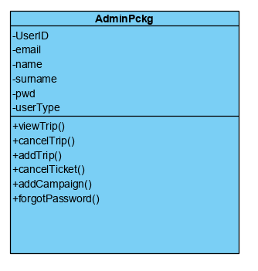

Officer Package

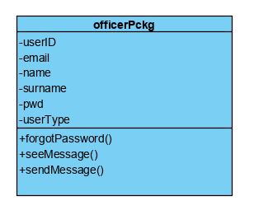

Registered User Package

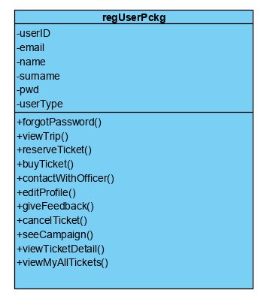

Visitor Package

